I used the value of N as 100000000 and the commands: time ./trap_omp1 and time ./trap_omp2 to compute the time.

trap_omp1.c using Critical:



trap_omp1.c using Atomic:

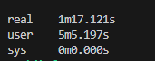

trap_omp2.c using Reduction:



My laptop has 4 cores. Reduction is very fast in comparison to atomic and critical parallelization.